1. **Experiment:** Cell proliferation assessment by cell counting method under acidic condition
2. **Time:** 2025.07.10-2025.07.29
3. **Member:** Xudong Tang, Yang Jin, Binxuan Zhang, Kaiqing Zhang, Xuantong Liu
4. **Materials:** Cell culture flasks, automated cell counter, pipettes and pipette tips, cell culture medium, incubator, centrifuge, cell culture dishes, sterile tubes or containers, growth curve plotting software, IL-2 , lactic acid
5. **Method:**
6. Experimental Group Design

From the sequence analysis of the single-cell sorting and planting survival experiment under acidic conditions, we obtained the top three sequences: B51G35R-G, B34G35R-G, and B51G9-G. Using their former design (B51G35R, B34G35R, and B51G9) and IL-2 as control groups. To test the proliferation of NK cells and T cells under acidic condition (15 mM lactic acid, adjusting pH to 6.4), and to show the differences between acidic environment (pH 6.4) and non-acidic environment (pH 7.4), the cells then were cultured in four different conditions as follows: NK cells under non-acidic condition, T cells under non-acidic condition, NK cells under acidic condition, T cells under acidic condition, and each of the sequences was tested independently under these conditions. Each groups then monitored the amplified curve for 7 days.

1. Cell Counting
2. Sample Collection: Place all culture flasks in cell incubator set at 37 ℃, 5% CO2. At predefined days of cell culture (Day 1-Day 7), cell samples were collected from each culture flask, and resuspended thoroughly.
3. Cell Counting: An aliquot of each cell sample was taken, and cells were counted using an automated cell counter. Recorded the cell numbers, the total cell number was recorded for each time point.
4. Calculation of Fold Expansion: The fold expansion of cells was calculated by comparing the cell numbers at different time points to the initial cell count (Day 0). The fold increase was determined using the formula: Fold Expansion = Cell Number at Time point t/Initial Cell Number (Day 0)
5. Plotting the Growth Curve: Using graphing software, a cell growth curve was generated by plotting the fold expansion (y-axis) against the days of culture (x-axis). This curve was used to analyze the proliferation rate and growth kinetics of the cultured cells over time.
6. **Result:**

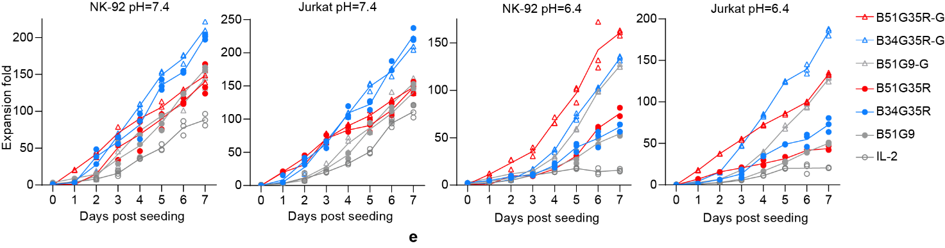

**Figure.1** Expansion fold of NK cells and T cells (Jurkat cells) at pH=7.4 and pH=6.4 over days post seeding for different constructs (B51G35R-G, B34G35R-G, B51G9-G, B51G35R, B34G35R, B51G9, IL-2). Data are presented as mean ± SD of three independent biological replicates.